Salt River Project (SRP) Thermal Mass
Cooling Load/Sensible and Latent Heat Analysis
ME476C Section 1

Author: Courtney Hiatt
Date: 5/1/2024

Contents
Introduction 3
Assumptions 3
Part 1. Cooling Load 3
Part 2. Latent and Sensible Heat of Materials 5
Mathematical Modeling/Software Calculations 6
Part 1. Cooling Load in Excel 6
Part 2. Latent and Sensible Heat in MATLAB 8
There are two MATLAB files used for the latent and sensible heat calculations. The first is a function that uses equation 7, equation 8, and equation 9 to determine how much heat the material is releasing when being cooled. These equations are rearranged by adding together the latent and sensible heat, and rearranging to solve for the mass, giving the following equation. 8
Results/Diagrams 9
Part 1. Cooling Load 9
Part 2. Sensible and Latent Heat 10
Conclusion and Analysis 13
References: 14
Appendix: 15

Introduction
Air conditioning is a large contributor to the energy demand in Maricopa County. The overarching goal of this project is to create a thermal mass that charges during the Salt River Project (SRP) off peak hours, and discharges cool air during peak hours. This will decrease the demand for energy during peak hours, and save SRP as well as customers money.
To calculate the cooling load (Q), the 1997 ASHRAE cooling load method is used to determine the smallest and largest possible values of Q based on the types of materials homes are built of. These calculations are done in Excel. [1] This is then compared to numbers found by the National Renewable Energy Lab (NREL).
Once the amount of energy necessary to keep the house cool during peak hours is determined, the next step is determining the mass and volume of the material needed to absorb adequate heat from the house during that time, effectively keeping it cool. This report answers the question of how much material we will need for the design, as well as how much it will cost.
This analysis then provides a MATLAB function that inputs material specific properties such as the specific heat and heat of fusion and uses heat transfer formulas to determine the amount of material needed to keep the house cool. The values for Q found previously are inputted into the MATLAB code, which can then be quickly applied to a variety of materials to compare the mass and volume needed to keep a house cool. This then influences the size of the system, as well as the price.

Assumptions

Part 1. Cooling Load
The peak hours for SRP can be found at the SRP time of use plan. [2] The peak hours are between 2-8PM.
The formulas from the ASHRAE handbook are given below to calculate the cooling load in BTU/hr. This can then be converted into energy by multiplying Q by the number of hours that the system is running.
$Q_{roof}=U_{roof}*A_{roof}*{CLTD}_{corrected}$ Equation 1
$Q_{windows}=U_{windows}*A_{windows}*{CLTD}_{corrected}$ Equation 2
$Q_{walls}=U_{walls}*A_{walls}*{CLTD}_{corrected}$ Equation 3
$Q_{total}=Q_{roof}+Q_{windows}+Q_{walls}$ Equation 4
${CLTD}_{corrected}=CLTD+\left(78-TR\right)+(TM-85)$ Equation 5
$TM=T_{max}-(\frac{DR}{2})$ Equation 6

Where
$Q$ = cooling load (BTU/hr)
$U$ = coefficient of heat transfer (Btu/hr*ft^2*F)
$A$ = area (ft^2)
$CLTD$ = cooling load temperature difference (F)
${CLTD}_{corrected}$ = CLTD adjusted for indoor and outdoor temperatures (F)
$TR$ = indoor room temperature (F)
$TM$ = mean outdoor temperature (F)
$T_{max}$ = max outdoor temperature (F)
$DR$ = daily range (F)
The cooling load is calculated in Excel. The initial data is given below with the majority of the values coming from the 1997 ASHRAE handbook based on the Phoenix Sky Harbor airport. The average area of the exterior walls on a home is from the Siding Authority estimator. [3] The average roof surface area is found from BFM roofing estimates. [4]
Table 1. ASHRAE Data
Initial Data
Latitude | 33.43
Longitude | 112.02 | F
Outdoor Dry Bulb | 110 | F
Outdoor Wet Bulb | 80 | F
Daily Range | 23 | F
Area of Wall - North Facing | 395 | ft^2
Area of Wall - South Facing | 395 | ft^2
Area of Wall - East Facing | 395 | ft^2
Area of Wall - West Facing | 395 | ft^2
Area of Roof | 1700 | ft^2
Area of Windows | 100 | ft^2
U Walls | 0.074 | Btu/h*ft^2*F
U Roof | 0.066 | Btu/h*ft^2*F
U Windows | 0.55 | Btu/h*ft^2*F

The CLTD values for each wall, window, and roof are determined for different materials by the authors of the 1997 ASHRAE handbook. These values are copied over into Excel for the peak hours from 2-8PM (given in the 24 hour clock as 14-20) for each side of the wall, the roof, and windows. The values are given below.
Table 2. CLTD Values
 | CLTD values (F)
Hour | Roof 14 | Wall 16 North | Wall 16 East | Wall 16 South | Wall 16 West | Windows (Conduction Load)
14 | 32 | 9 | 26 | 11 | 11 | 13
15 | 36 | 10 | 28 | 14 | 12 | 14
16 | 39 | 11 | 30 | 17 | 14 | 14
17 | 42 | 13 | 31 | 20 | 17 | 13
18 | 44 | 14 | 31 | 23 | 20 | 12
19 | 45 | 16 | 32 | 25 | 25 | 10
20 | 45 | 17 | 32 | 27 | 30 | 8

Table 3. CLTD Values
 | CLTD values (F)
Hour | Roof 1 | Wall 1 North | Wall 1 East | Wall 1 South | Wall 1 West | Windows (Conduction Load)
14 | 88 | 27 | 31 | 42 | 11 | 13
15 | 88 | 29 | 30 | 59 | 12 | 14
16 | 83 | 29 | 30 | 73 | 14 | 14
17 | 73 | 28 | 28 | 80 | 17 | 13
18 | 60 | 29 | 25 | 79 | 20 | 12
19 | 43 | 27 | 20 | 62 | 25 | 10
20 | 26 | 17 | 14 | 32 | 30 | 8

Part 2. Latent and Sensible Heat of Materials
The following diagram shows a general phase change diagram, as well as the equations for latent and sensible heat.
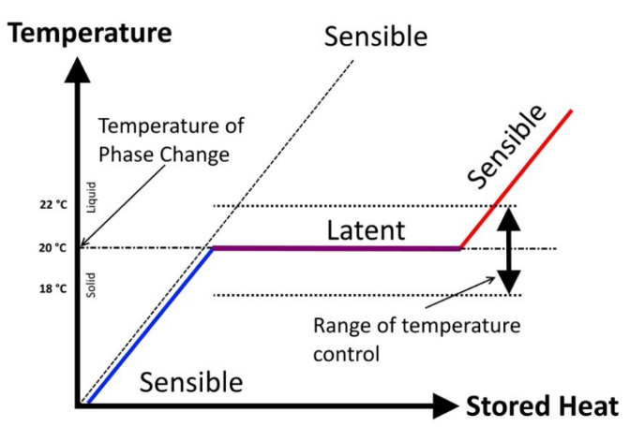
Graph 1. Phase Change Diagram [5]
$Latent Heat= q=m*c$ Equation 7
$Sensible Heat=q=m*C*ΔT$ Equation 8
$D=m/V$ Equation 9

Where
$q$ = heat (kJ)
$m$ = mass (kg)
$c$ = heat of fusion (kJ/kg)
$C$ = specific heat (kJ/kg*C)
T = temperature (C)
$V$ = volume (m^3)
$D$ = density (kg/m^3)

The following data is collected for water and concrete. These are found in the engineering toolbox. [6]
Table 4. Material Properties
 | Water | Concrete
Heat of fusion (kJ/kg) | 334 | n/a
Specific heat (kJ/kg) | 4.184 | 1
Temperature of fusion (C) | 0 | 1200
Density | (varies for temp) | 2300
Cost ($/kg) | 0.0002189 | 0.10

Mathematical Modeling/Software Calculations

Part 1. Cooling Load in Excel
Excel is used to calculate the cooling load using the assumptions. The following table is created by taking the CLTD values and using equation 5 and equation 6 to find CLTD corrected, then equation 1 to find the value of Q for the roof that allows the smallest amount of heat in. This is repeated for the roof that lets in the most heat to find the max Q value.
Table 5. Roof Calculation in Excel
Min Roof - Assume Roof 14
Hour | CLTD (F) | CLTD corrected (F) | Qdot (Btu/hr)
14 | 32 | 45.5 | 5105.1
15 | 36 | 49.5 | 5553.9
16 | 39 | 52.5 | 5890.5
17 | 42 | 55.5 | 6227.1
18 | 44 | 57.5 | 6451.5
19 | 45 | 58.5 | 6563.7
20 | 45 | 58.5 | 6563.7
Total |  |  | 42355.5

Similar calculations are used to find Q for the windows using equation 2. An example of these calculations are given below.
Table 6. Window Calculation in Excel
Min Windows (Conduction Load)
Hour | CLTD (F) | CLTD corrected (F) | Q (Btu/hr)
14 | 13 | 26.5 | 1457.5
15 | 14 | 27.5 | 1512.5
16 | 14 | 27.5 | 1512.5
17 | 13 | 26.5 | 1457.5
18 | 12 | 25.5 | 1402.5
19 | 10 | 23.5 | 1292.5
20 | 8 | 21.5 | 1182.5
Total |  |  | 9817.5

Similar calculations are used to find Q for the walls facing North, East, South, and West using equation 3. An example for the North and East walls are given below. For more details on all the walls for the minimum and maximum calculations, look at the Excel document.
Table 7. Wall Calculation in Excel
Min North Wall - Assume Wall 16 |  |  |  | Min East Wall - Assume Wall 16
Hour | CLTD (F) | CLTD corrected (F) | Qdot (Btu/hr) | Hour | CLTD (F) | CLTD corrected (F) | Qdot (Btu/hr)
14 | 9 | 22.5 | 657.675 | 14 | 26 | 39.5 | 1154.585
15 | 10 | 23.5 | 686.905 | 15 | 28 | 41.5 | 1213.045
16 | 11 | 24.5 | 716.135 | 16 | 30 | 43.5 | 1271.505
17 | 13 | 26.5 | 774.595 | 17 | 31 | 44.5 | 1300.735
18 | 14 | 27.5 | 803.825 | 18 | 31 | 44.5 | 1300.735
19 | 16 | 29.5 | 862.285 | 19 | 32 | 45.5 | 1329.965
20 | 17 | 30.5 | 891.515 | 20 | 32 | 45.5 | 1329.965
Total |  |  | 5392.935 | Total |  |  | 8900.535

The final Q is found by adding together all of the Q values for the walls, windows, and roof using equation 4.
Table 7. Q Values by hour
Total Min Qdot |  | Total Max Qdot
Hour | Q (Btu/hr) | Hour | Q (Btu/hr)
14 | 9807.13 | 14 | 90
15 | 10515.54 | 15 | 99
16 | 11085.98 | 16 | 109
17 | 11630.65 | 17 | 119
18 | 12004.66 | 18 | 128
19 | 12299.16 | 19 | 139
20 | 12423 | 20 | 149
Average | 11395.16 | Average | 119
Values of q are calculated by multiplying each Q value for the hour by one hour, then adding it up at the end. This is converted between units to be used in the calculations for latent and sensible heat in MATLAB.
Table 8. Excel Sum Q Values
Max Q Values (Btu) |  | Max Q Values (kJ) |  | Max Q Values (kWh)
Roof | 62327.1 | Roof | 65755.091 | Roof | 18.26
Windows | 9817.5 | Windows | 10357.463 | Windows | 2.88
Walls | 41214.3 | Walls | 43481.087 | Walls | 12.08
Total | 113358.9 | Total | 119593.64 | Total | 33.22
Min Q Values (Btu) |  | Min Q Values (kJ) |  | Min Q Values (kWh)
Roof | 42355.5 | Roof | 44685.053 | Roof | 12.41
Windows | 9817.5 | Windows | 10357.463 | Windows | 2.88
Walls | 27593.12 | Walls | 29110.742 | Walls | 8.09
Total | 79766.12 | Total | 84153.257 | Total | 23.38

Part 2. Latent and Sensible Heat in MATLAB

There are two MATLAB files used for the latent and sensible heat calculations. The first is a function that uses equation 7, equation 8, and equation 9 to determine how much heat the material is releasing when being cooled. These equations are rearranged by adding together the latent and sensible heat, and rearranging to solve for the mass, giving the following equation.
$m=Q/(C*ΔT+c)$ Equation 10
In MATLAB, this equation is shown below, as well as the formula that converts that mass into volume using equation 9.
Mass = EnergyValues./(SpecificHeat*dT+HeatofFusion); %kg
Volume = Mass/MinDensity;

The function also checks if the material is a phase change material by checking if the heat of fusion occurs within the temperature change. If it does not, then it automatically sets the heat of fusion to 0.
if (LowestTemp > TempofFusion) || (TempofFusion > RoomTemp)
HeatofFusion = 0;
end

The function then produces a variety of graphs and tables displaying information regarding the mass, volume, and price of material needed. The MaterialPropertiesDriver.m calls on the function MaterialProperties by giving information about the material and plugging it into the function. Using the assumptions for the values found above, the following code is produced for water. The same is done for concrete, see the Appendix for more details..
%Properties of water
Water = 'Water';
WaterHeatofFusion = 334; %kJ/kg
WaterSpecificHeat = 4.187; %kJ/kgC
TempofFusion = 0; %deg C
WaterDensityMatrix = [-50 -40 -35 -30 -25 -20 -15 -10 -5 0 1 4 10 15 20 25 30 35 40 45 50 55 60 65 70; 921.6 920.8 920.4 920 919.6 919.4 919.4 918.9 917.5 916.2 999.90 999.97 999.70 999.10 998.21 997.05 995.65 994.03 992.22 990.21 998.04 985.69 983.21 980.55 977.76]; %kg/m3
WaterCost = 0.0002189;
MaterialProperties(Water, WaterHeatofFusion, TempofFusion, WaterSpecificHeat, WaterDensityMatrix, MinEnergyRequirement, MaxEnergyRequirement, LowestTemp, WaterCost)

The minimum and maximum energy requirements are determined based on the cooling load calculations, and plugged into MATLAB through the following:
LowestTemp = -1; %deg C
MinEnergyRequirement = 84153; %kJ
MaxEnergyRequirement = 119593; %kJ

Results/Diagrams

Part 1. Cooling Load
Table 9. Cooling Load Results
Max Q Values (Btu) | Max Q Values (kJ) | Max Q Values (kWh)
113358.9 | 119593.64 | 33.22
Min Q Values (Btu) | Min Q Values (kJ) | Min Q Values (kWh)
79766.12 | 84153.257 | 23.38
Max Qdot Values (Btu/h) | Max Qdot Values (kJ/h) | Max Qdot Values (kW)
16194.12857 | 17084.80564 | 4.745646463
Min Qdot Values (Btu/h) | Min Q Values (kJ/h) | Min Qdot Values (kW)
11395.16 | 12021.8938 | 3.339321441

Part 2. Sensible and Latent Heat
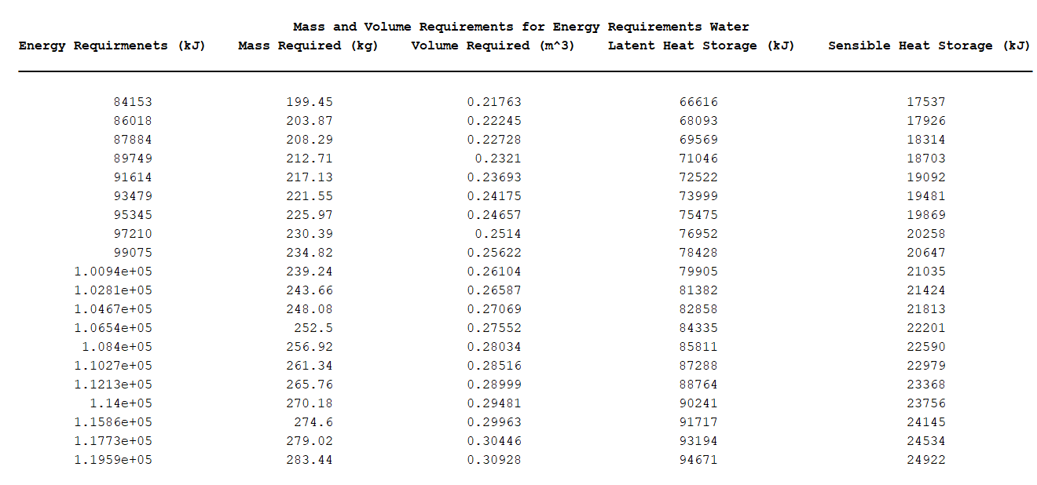
Table 10. Water Results

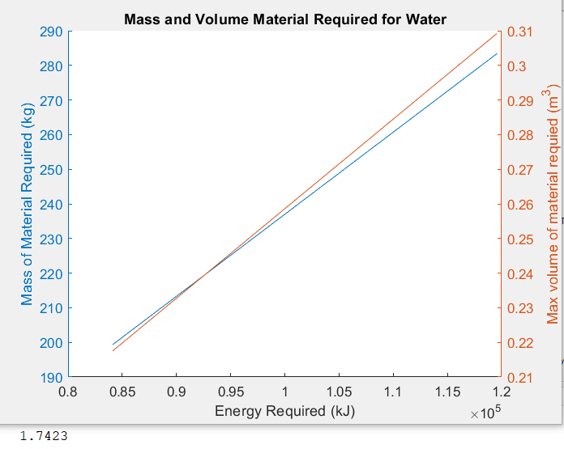
Graph 2. Mass and Volume Material Required for Water

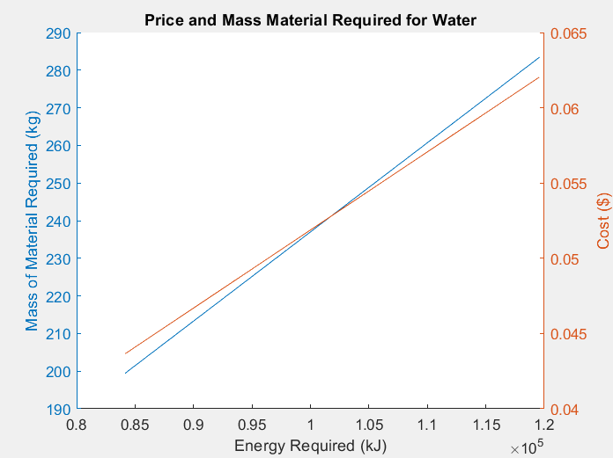
Graph 3. Mass and Price Material Required for Water

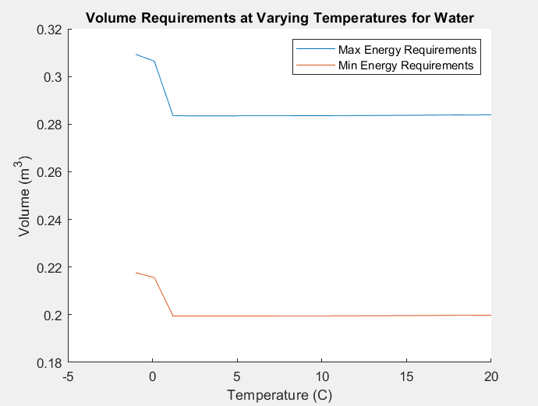
Graph 4. Volume Requirements at Varying Temperatures for Water

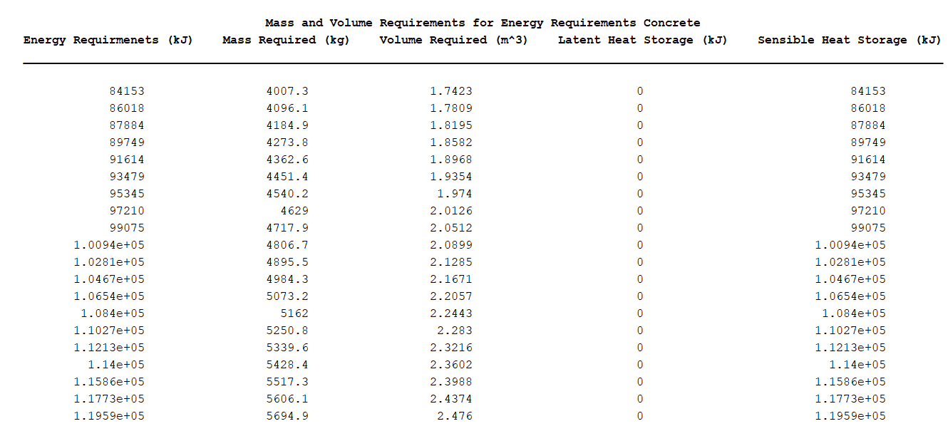
Table 11. Concrete Results

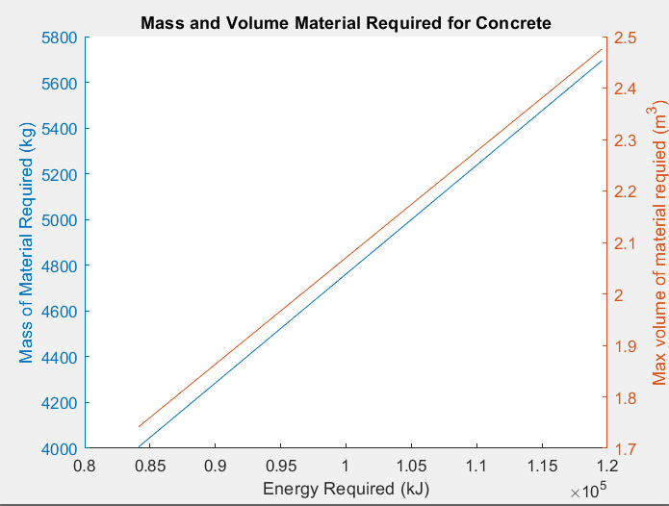
Graph 5. Mass and Volume Material Required for Concrete

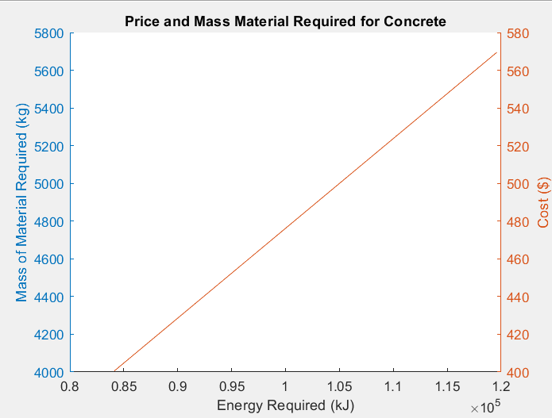
Graph 6. Mass and Price Material Required for Concrete

Conclusion and Analysis
The cooling load I calculated can be compared to the cooling load found by the National Renewable Energy Lab (NREL). They found that for hot-dry and mixed-dry climates, the average thermal load per year is 1.83M MBTU/yr. [7]
When converting this down to Btu/hr, this is approximately 208 BTU/hr. Our average minimum calculated load is 11395 Btu/hr, which is significantly higher than their values. However, this could be explained because their value includes the cooler winter months and the power used through the night. Phoenix is on the high end of the hot climate, so accounting for that, our values would be expected to be higher than a mixed climate as well. Our values only account for the peak hours when AC is running at full power.
Through this analysis, it is clear that the price and volume of water is significantly lower than the price that would be required to have adequate cooling capacity with concrete. However, water may have other properties that could be disadvantageous, specifically because it expands. This MATLAB code that I created could also be used to quickly calculate how much it will cost to use other materials if we decide to consider them.
The values calculated for the material properties can be considered in the Net Present Value calculations that impact the spider charts. The tool creates an effective way for comparing the properties of materials visually and through tables, and determining which factors lead to the lowest costs.

References:
[1] R. Crawford, K. Herold, A. Jacobi, and T. Kuehn, 1997 ASHRAE Handbook, I-P. 1997.
[2] “SRP Time-of-Use (TOU) Price Plan | SRP.” Accessed: Feb. 03, 2024. [Online]. Available: https://www.srpnet.com/price-plans/residential-electric/time-of-use
[3] “Siding Calculation & Exterior Sq. Ft. Estimation Methods,” Siding Authority. Accessed: Apr. 29, 2024. [Online]. Available: https://sidingauthority.com/estimation-calculator/
[4] B. Tarver, “How Much Does the Average Roof Replacement Cost,” B&M Roofing | Commercial & Residential Roofing in Colorado. Accessed: Apr. 29, 2024. [Online]. Available: https://bmroofing.com/how-much-does-the-average-roof-replacement-cost/
[5] “Figure 1. Sensible heat vs. latent heat and temperature control during...,” ResearchGate. Accessed: Mar. 16, 2024. [Online]. Available: https://www.researchgate.net/figure/Sensible-heat-vs-latent-heat-and-temperature-control-during-the-phase-change-7_fig1_312868057
[6] “Water - Thermophysical Properties.” Accessed: Apr. 29, 2024. [Online]. Available: https://www.engineeringtoolbox.com/water-thermal-properties-d_162.html
[7] A. Speake, E. J. H. Wilson, Y. Zhou, and S. Horowitz, “Component-level analysis of heating and cooling loads in the U.S. residential building stock,” Energy Build., vol. 299, p. 113559, Nov. 2023, doi: 10.1016/j.enbuild.2023.113559.

Appendix:
function MaterialProperties(Material,HeatofFusion, TempofFusion, SpecificHeat, DensityMatrix, MinEnergyRequirement, MaxEnergyRequirement, LowestTemp, Costperkg)
% AUTHOR: Courtney Hiatt
% DATE: 3/26/2024
% INPUTS: Material Properties and Energy Requirements
% OUTPUTS: Graphs and Tables regarding mass and volume requirements

% This MATLAB code inputs the material properties and minimum to maximum
% energy requirements and outputs data and graphs on the required mass,
% volume, and price required to run the AC through the night.

%Initializing values
RoomTemp = 20; %C
dT = RoomTemp-LowestTemp; %C
T = linspace(LowestTemp,RoomTemp,20)'; %C
density = interp1(DensityMatrix(1,:),DensityMatrix(2,:),T); %kg/m^3
MinDensity = min(density); %kg/m^3
EnergyValues = linspace(MinEnergyRequirement, MaxEnergyRequirement, 20)'; %kJ
Mass = EnergyValues./(SpecificHeat*dT+HeatofFusion); %kg
Volume = Mass/MinDensity;
Latent = Mass*HeatofFusion;
Sensible = EnergyValues-Latent;
Cost = Mass*Costperkg;

% If the material does not go through phase change, the latent heat is 0,
% and this can be accounted for by changing the heat of fusion to 0.
if (LowestTemp > TempofFusion) || (TempofFusion > RoomTemp)
HeatofFusion = 0;
end

%Plotting and creating a table of the mass and volume required for the
%minimum to maximum energy requirements
A = [EnergyValues, Mass, Volume, Latent, Sensible];
Table1 = array2table(A, 'VariableNames', {'Energy Requirmenets (kJ)', 'Mass Required (kg)', 'Volume Required (m^3)', 'Latent Heat Storage (kJ)', 'Sensible Heat Storage (kJ)'});
text = 'Mass and Volume Requirements for Energy Requirements ';
txt = append(text,Material);
Table1 = table(Table1, 'VariableNames', {txt})

figure
hold on
text = 'Mass and Volume Material Required for ';
txt = append(text,Material);
title(txt)
xlabel('Energy Required (kJ)')
yyaxis left
plot(EnergyValues,Mass)
ylabel('Mass of Material Required (kg)')
yyaxis right
plot(EnergyValues,Volume)
ylabel('Max volume of material requied (m^3)')
hold off

figure
hold on
text = 'Price and Mass Material Required for ';
txt = append(text,Material);
title(txt)
xlabel('Energy Required (kJ)')
yyaxis left
plot(EnergyValues,Mass)
ylabel('Mass of Material Required (kg)')
yyaxis right
plot(EnergyValues,Cost)
ylabel('Cost ($)')
hold off

%This creates a table and plot of the changes in volume for the max and min energy
%requirement
MaxMass = MaxEnergyRequirement./(SpecificHeat*dT+HeatofFusion); %kg
MaxVolumes = MaxMass./density; %m^3
MinMass = MinEnergyRequirement./(SpecificHeat*dT+HeatofFusion); %kg
MinVolumes = MinMass./density; %m^3

B = [T, MaxVolumes];
Table2 = array2table(B, 'VariableNames', {'Temperature (C)', 'Volume'});
text = 'Volume Requirements for Maximum Energy Requirements ';
txt = append(text,Material);
Table2 = table(Table2, 'VariableNames', {txt})
C = [T, MinVolumes];
Table3 = array2table(C, 'VariableNames', {'Temperature (C)', 'Volume (m^3)'});
text = 'Volume Requirements for Minimum Energy Requirements ';
txt = append(text,Material);
Table3 = table(Table3, 'VariableNames', {txt})

figure
hold on
plot(T,MaxVolumes)
plot(T,MinVolumes)
xlabel('Temperature (C)')
ylabel('Volume (m^3)')
text = 'Volume Requirements at Varying Temperatures for ';
txt = append(text,Material);
title(txt)
legend('Max Energy Requirements', 'Min Energy Requirements')
hold off

end

% AUTHOR: Courtney Hiatt
% DATE: 3/26/24
% This code is the driver for the material properties function and outputs
% mass, volume, and cost requirements for different materials.

clc
clear all

LowestTemp = -1; %deg C
MinEnergyRequirement = 84153; %kJ
MaxEnergyRequirement = 119593; %kJ

%Properties of water
Water = 'Water';
WaterHeatofFusion = 334; %kJ/kg
WaterSpecificHeat = 4.187; %kJ/kgC
TempofFusion = 0; %deg C
WaterDensityMatrix = [-50 -40 -35 -30 -25 -20 -15 -10 -5 0 1 4 10 15 20 25 30 35 40 45 50 55 60 65 70; 921.6 920.8 920.4 920 919.6 919.4 919.4 918.9 917.5 916.2 999.90 999.97 999.70 999.10 998.21 997.05 995.65 994.03 992.22 990.21 998.04 985.69 983.21 980.55 977.76]; %kg/m3
WaterCost = 0.0002189;
MaterialProperties(Water, WaterHeatofFusion, TempofFusion, WaterSpecificHeat, WaterDensityMatrix, MinEnergyRequirement, MaxEnergyRequirement, LowestTemp, WaterCost)

%Properties of concrete
Concrete = 'Concrete';
ConcreteHeatofFusion = 0; %kJ/kg
ConcreteSpecificHeat = 1; %kJ/kgC
ConcreteDensityMatrix = [-100,0, 80, 95, 180; 2300, 2300, 2300, 2300, 2254];
ConcreteTempofFusion = 1200; %deg C
ConcreteCost = 0.10;
MaterialProperties(Concrete, ConcreteHeatofFusion, ConcreteTempofFusion, ConcreteSpecificHeat, ConcreteDensityMatrix, MinEnergyRequirement, MaxEnergyRequirement, LowestTemp, ConcreteCost)

